**Agricultural Cycles:**

**Livestock Market Assessment and Long Term Prospective**

**(Beef Cattle and Hogs)**

Lee Schulz

Assistant Professor / Extension Livestock Economist

Department of Economics

Iowa State University

In the current economic environment livestock producers face numerous challenges that place constraints on the ability of this sector of agriculture to sustainably grow and prosper. Some of these factors include rising and volatile input costs, potential for severe equity drain, and broader economic influences. With these and other developing influences bombarding producers, and the likelihood of other challenges arising in the future, stakeholders are left pondering the economic situation facing the industry. Livestock production, like agriculture in general, is a notoriously cyclical industry. Given the livestock sector’s previous runs of prosperity as well as challenging times, it is logical to ask what the future might hold. This paper explores the relationship among supplies, prices and incomes, cost of production, and demand to examine some of the key factors that shape the cyclical pattern in livestock returns.

**Supplies**

Despite improved returns for cow-calf producers the last few years, drought in the Southern Plains in 2011 and much of the U.S. in 2012 further delayed expansion in the industry and brought about additional reduction in cattle numbers. Looking at the beef cow herd, the foundation of the total cattle inventory, a distinct cycle of growth and liquidation has defined the industry (figure 1). By 2013, one of the longest and most severe liquidation phases in the history of cattle cycle has reduced the U.S. cattle herd to its lowest level in over fifty years - well below the trough of the previous cycle. Recent cattle cycles have become much less pronounced, with shorter periods of increase and more prolonged phases of decrease. Much of this deviation from historical trends is likely attributed to abnormal weather (leading to increased variability in stocking rates), decreases in the available land base, production being impacted by replacement rates, and input and output price variability and volatility (which affects producer’s foresight of prices). Future cattle cycles will likely not have as much in common with past cycles and investment strategies will need to be tailored to meet this unknown, or emerging, new pattern.

[figure 1 about here]

Figure 2 shows the hog cycle in percentage change terms, or the repetitive increases and decreases of output by hog producers. The hog cycle runs three to four years from peak to peak or trough to trough. The cycle is caused by the roughly one-year lag from breeding a sow to marketing a pig and another roughly one-year lag for the decision process of producers. Decisions of producers and the length of that final lag, depends on the rate at which profits are accumulated (which either attracts new entrants or allows existing producers to expand) or money is lost (which drives contraction). During the 1970s, year-to-year changes of +/- 20 percent were not unusual; a result of hogs produced by firms that were “in” hog production when conditions were profitable and “out” when conditions were unfavorable to production. A flattening of the cycle has occurred over time due to technology developments and consequent changes in industry structure. However, production levels do still vary as profitable returns attract new entrants or allow existing producers to expand and negative returns drive contraction. For example, profitable returns to hog production from 2004 through 2006 brought about expansion that was realized from 2006 through mid-2008. Similarly, profits in 2010 resulted in increased production from mid-2011 through 2012, while significant losses in 2012 reduced production in 2013 below year ago levels.

[figure 2 about here]

**Prices and Incomes**

Price volatility has increased to unprecedented levels over the last several years and can be attributed to factors including domestic and foreign political and economic policy, changing global supply and demand balance, and natural occurrences (e.g., weather) affecting supply. A high level of volatility, in isolation, does not necessarily present a challenge for producers. For example, volatile but relatively high prices can provide an opportunity for profitability given the availability of suitable risk management options. Generally, however, higher volatility presents greater management challenges for producers because of the narrow operating margin of most farms and the fixed nature of farm assets.

Prices are volatile and difficult to predict, however we have built up some understanding of how prices react to changes in the economic environment. Recession has become a buzzword. Livestock are marketed and meat produced within a limited period of time, and therefore prices heavily reflect creation and usage rates. As a result, prices often fall during recessions, due to a fall in demand. A fall is not guaranteed, because production may also downsize to compensate, but this usually occurs after a significant delay – so low prices may persist for quite some time.

With the help of historical data, we can see what has typically happened to livestock prices before, during, and after a recession (figure 3). For example, from November 1973 to March 1975, calf, cow, and steer and heifer prices were dragged down from their peak due to a crash in the market. These lower prices persisted for more than two years. However, in 1979, prices made a new high, higher than the 1973 peak. Similar trends have occurred during the January – July 1980, July 1981 – November 1982, July 1990 – March 1991, March – November 2001, and December 2007 – June 2009 recessions. A trend that does become evident is new peaks in prices after recessions. Two dimensions likely contribute to these higher prices after recessions: first, production decreases and meat supplies tightening, and secondly, various monetary steps to revive the economy and promote demand, including interest rate cuts, relief packages, tax cuts, etc.

[figure 3 about here]

There has been a significant shift in the relative contribution to cash farm revenue over time; livestock receipts representing a declining share of farm revenue, while income from crops has risen. Cattle and calves have historically represented about 20 percent of farm-level cash receipts. Cash receipts from marketing cattle and calves peaked during the years of 1972 (30 percent), 1979 (27 percent), and 1988 (24 percent) (figure 4). Meanwhile, corn and soybeans have historically represented between 5 and 10 percent of total cash receipts.  In 2007, cattle and calves fell below 20 percent of farm-level cash receipts, and since then, have hovered at about 17 percent, while corn and soybeans have represented about one-fourth of total cash receipts. Hogs have historically represented about 8 percent of farm-level cash receipts and peaked from 1950 to 1954 (11 percent). In 2006, hogs fell below 6 percent of farm-level cash receipts, and since then, have hovered at about 5 percent.

[figure 4 about here]

**Costs**

Higher livestock prices and cash receipts are not the only numbers rising. Production costs have climbed to historic levels. The main driver of higher production costs has been feed, which may account for 60 to 70 percent of total production costs in any given year. The rise in feed prices has been due primarily to the jump in feed grain. From 2007 through 2012-13, the price for corn, which constitutes over 90 percent of feed grains used, increased 197 percent (table 1). During that same time period the price received for live cattle and live hogs increased only 38 percent and 37 percent, respectively. From 2007 to 2012-13 prices paid for feeder cattle and feeder pigs increased 32 percent and 5 percent, respectively.

[table 1 about here]

To further explore the relationship among livestock prices and corn prices, correlation matrices of these series were computed (table 2). Livestock prices and corn prices are highly correlated and the relationship has strengthened when comparing the periods January 1999 – December 2006 and January 2007 – May 2013. When measured in percentage change by month, the correlation between livestock prices and corn price is weaker; however, there are a few noteworthy patterns. Feeder cattle prices responded predictably to corn prices, moving lower as corn prices escalate. However, this relationship has weakened in recent years as continued tightening of feeder supplies has supported feeder cattle prices. Also, the link between changes in live hog price and corn price has strengthened.

[table 2 about here]

A high price ratio of live cattle to corn, or live hogs to corn, (a comparison between revenue received and the greatest variable cost) is a strong incentive to production (figure 5, figure 6). This ratio can get very large when corn becomes less expensive. For example, in 1986-1988 this ratio peaked for cattle and hogs, when the payment in-kind (PIK) program rolled millions of bushels out of storage and onto world markets. In 2005, this ratio saw another peak, most notably in cattle production, reflecting the strong prices received for live cattle.

[figure 5 about here]

[figure 6 about here]

Table 3 shows the average year/year changes in steers & heifers / corn and hogs / corn (i.e., feed price ratio) over the last 44 years during periods of downturns and upturns in the beef cow herd and hog slaughter. The steers & heifers / corn ratio has averaged a 1.38 percent increase per year during the period; overall the increase has totaled over 60 percent. The hogs / corn ratio has averaged a 0.65 percent increase per quarter while increasing in total over 112 percent over the period. Historically, an upturn in the beef cow herd (hog slaughter), has coincided with a decreasing feed price ratio, while a downturn in the beef cow herd (hog slaughter), has coincided with an increasing feed price ratio. However, the current downturn in the beef cattle herd has not coincided with an increase in the feed price ratio which further highlights the unknown, or emerging, new pattern to the cattle cycle.

[table 3 about here]

**Demand**

One of the most prevailing concerns in the industry is beef and pork demand. Obviously, if demand were strong enough, the margin squeeze felt by producers could be alleviated. Resistance to higher beef and pork prices will likely continue to grow. As a result, the relatively stable demand for beef and pork that has thus far persisted could begin to decline. The next several years will put demand in relatively uncharted waters so it is impossible to know exactly what to expect making it increasingly critical to monitor.

A clear distinction between quantity demanded and demand is necessary to comprehend demand, and the demand indices discussed below. Quantity demanded is the quantity of product consumers will purchase at a given price when all other factors are held constant. Demand is a schedule of quantities consumers would purchase over a range of prices. Per capita consumption is simply production (net volume of domestic production, cold storage adjustments, and international trade) divided by resident population and provides little information regarding demand when considered independently from prices. The concept of the demand index refers to mapping out changes in demand rather than quantity demanded.

So much discussion lately has revolved around shrinking beef and cattle supplies. Forecasts call for a large decrease in commercial slaughter in 2013 and repeated again in 2014. This may be partially offset by higher carcass weights, but not enough to offset the reduction in the number of animals. Expectations call for a net reduction in beef production in total and per capita moving forward. The question is how much will consumers pay for this reduced poundage? The table in figure 7 uses FAPRI estimates for per capita consumption from 2013 to 2017 and the calculated percent all fresh beef price change needed to hold demand constant. In other words, if demand is unchanged, there will be a significant upward push on retail beef prices in the next few years. As per capita supplies of beef are reduced to historically low levels in coming years, the willingness of some U.S. consumers to pay likely record high retail beef prices is paramount to monitor. The combination of higher prices and reduced per capita supplies will likely be met by more requests for beef quality and associated requirements for additional investment and management adjustments.

[figure 7 about here]

The strong supplies in the pork industry also underscores the heightened role realized demand strength will have on observed prices in the future. The table in figure 8 uses FAPRI estimates for per capita consumption from 2013 to 2017 and the calculated percent pork price change needed to hold demand constant. In other words, if demand is unchanged, there will be a downward push on retail pork prices in the next several years.

[figure 8 about here]

Consumers, more than ever, are demanding more information about how their food is produced and where their food comes from. As such, the beef and pork industries appear to be moving away from “all beef is equal” and “all pork is equal” highlighted by the dropping percent of fed cattle and hogs being sold via negotiated cash trade and the increasing role of premiums and discounts with eventual ties back to producers.

Furthermore, U.S. livestock producers operate in an increasingly global marketplace. The ability of these industries to send their products to the highest value market outlets and the comparative interest in countries worldwide to expand or adjust their meat consumption patterns will progressively influence economic prospects for the U.S. livestock industry moving forward. The growing and increasingly affluent world population is diverse with marked variation in preferences (i.e., price, cut preference, quality, phytosanitary issues, etc…). While it is nearly impossible to precisely predict events such as the Ractopamine/Paylean controversy producers are encouraged to recognize the fragility of export markets and be prepared for disruptions.

**Conclusions**

As industry stakeholders look to the rest of 2013 and beyond it is worth taking note of a few of the factors that may alter livestock production.

Drought recovery comes to mind as a major factor. Several key cattle producing states are still experiencing dry weather and others have not yet fully recovered from drought. This will limit herd growth in these areas. The recent drought, higher crop prices, and demand to shift pasture to crops has likely extended the liquidation phase of the current cattle cycle. In addition, this could lengthen the herd expansion phase, once the industry gets there, as growth may occur more slowly, as future expansion will be limited by the available resource base. For all livestock production it’s important to keep in mind that cost management drives a majority of the differences in returns and is likely even more critical in periods of drought response and recovery. This has a direct implication for who will lead expansion.

Price risk management will also play a major role in livestock production in the future. The reality of increasingly volatile markets sets the stage for very dynamic and challenging conditions as livestock producers are exposed to increasing amounts of both input and output price risk. It will be increasingly important to manage risk and managing margins and in doing so manage both sides of the profit equation, costs and output prices.

Finally, uncertainty “outside” the livestock industry is likely to persist. Issues regarding federal budget debates, farm bill details, national policy debates, regulations, public interest in food production, weather, and a host of other issues beyond the control of individual producers will continue to underpin an environment of higher uncertainty than most producers are accustom to and likely comfortable with. Ultimately, segments of the livestock industry that are most comfortable with this increasingly complex, uncertain, and dynamic business environment will be those who stay the course, reinvest, and expand their operations. Conversely, those less comfortable will have reduced prominence in the industry going forward. The net impact of this interplay will likely dictate the structure of the livestock industry moving forward.

**Figure 1. January 1 Beef Cow Inventory**

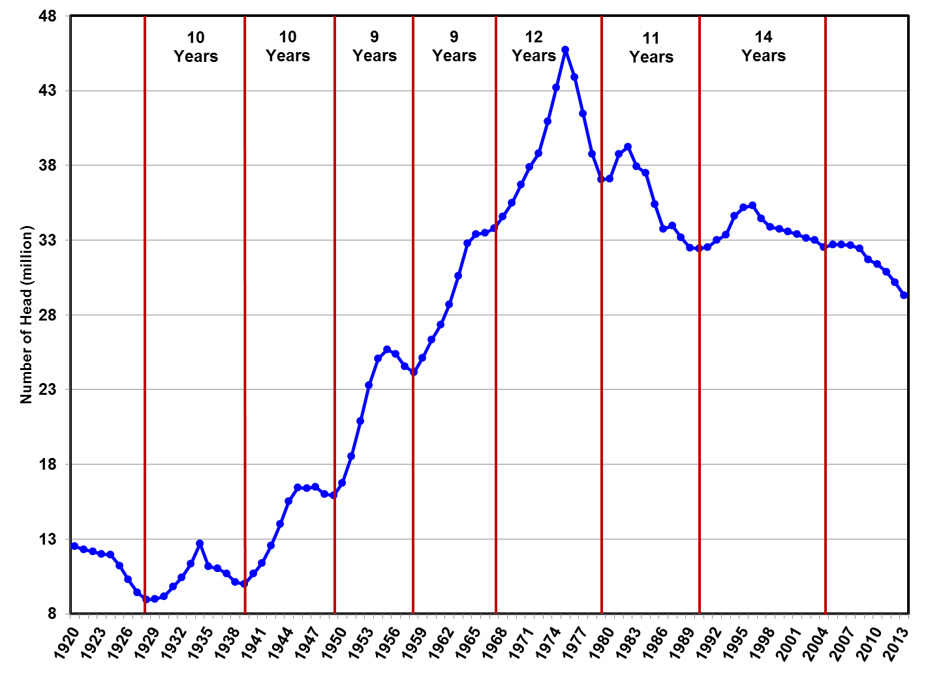

Data Source: USDA-NASS

**Figure 2. Commercial Hog Slaughter, U.S., Quarterly**

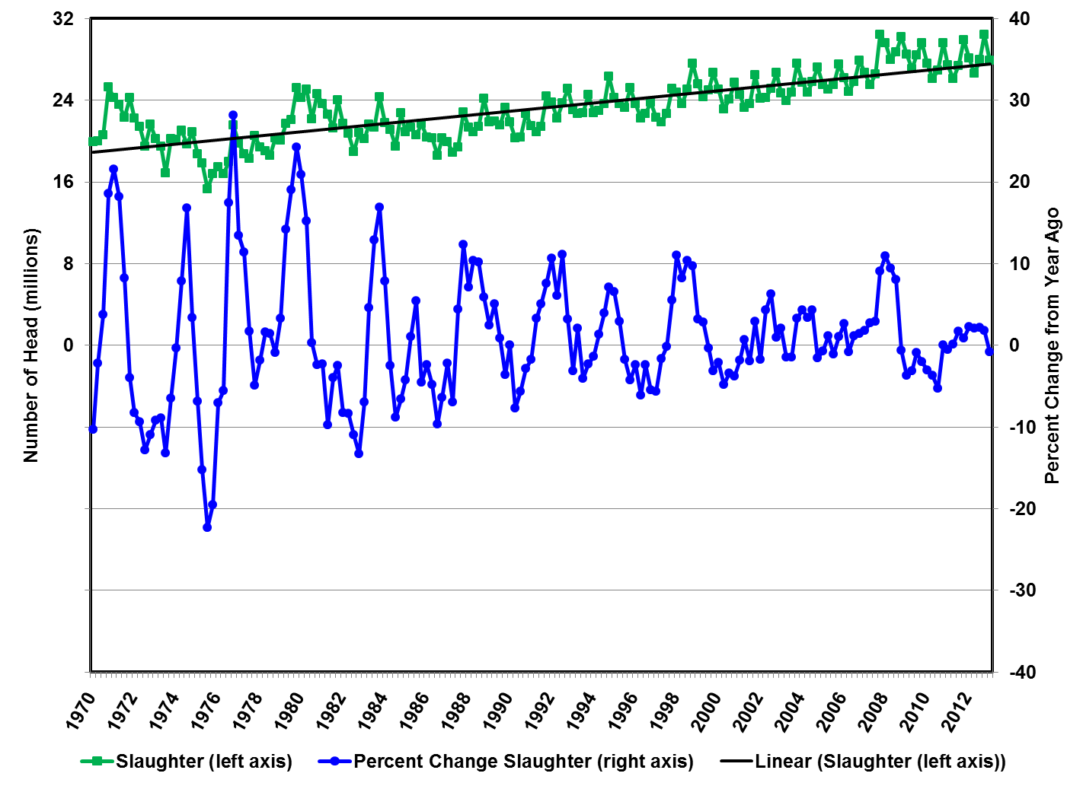

Data Source: USDA-NASS

**Figure 3. Prices Received for Cattle and Hogs, U.S., Monthly**

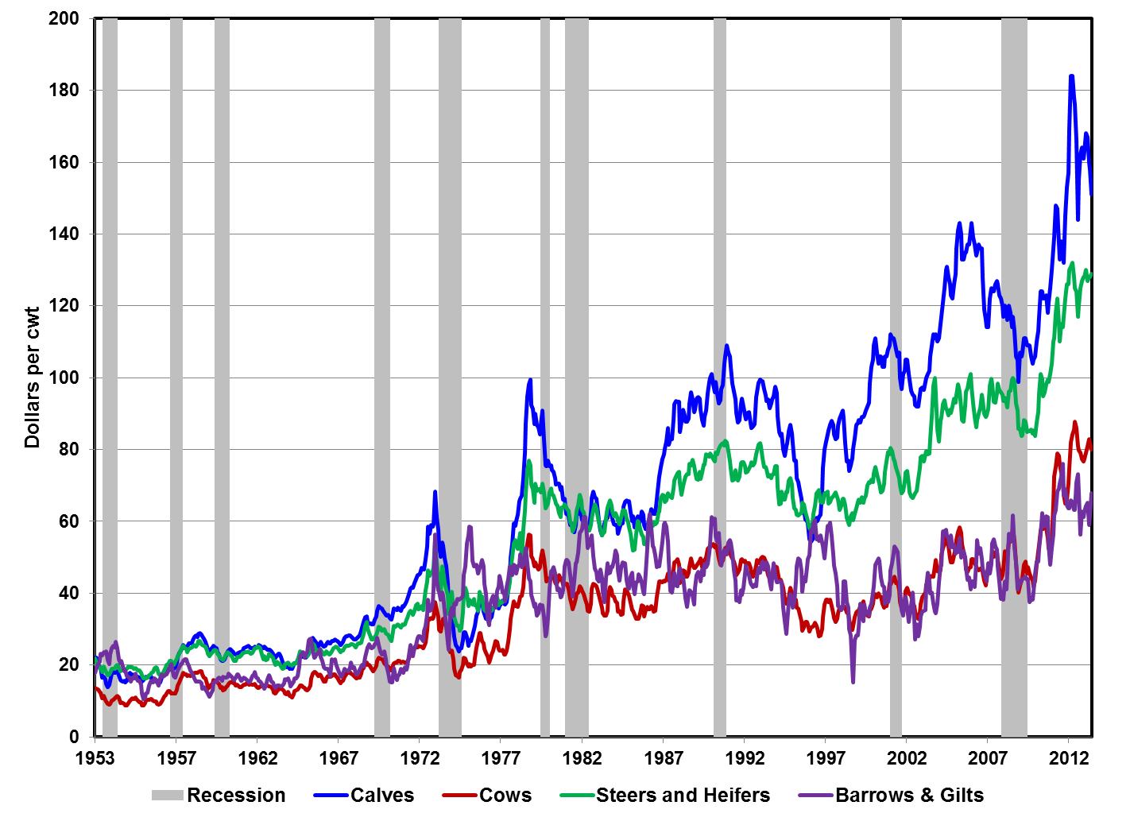

Data Source: USDA-NASS & NBER, Compiled and analysis by Lee Schulz

**Figure 4. Farm-Level Cash Receipts, U.S., Annual**

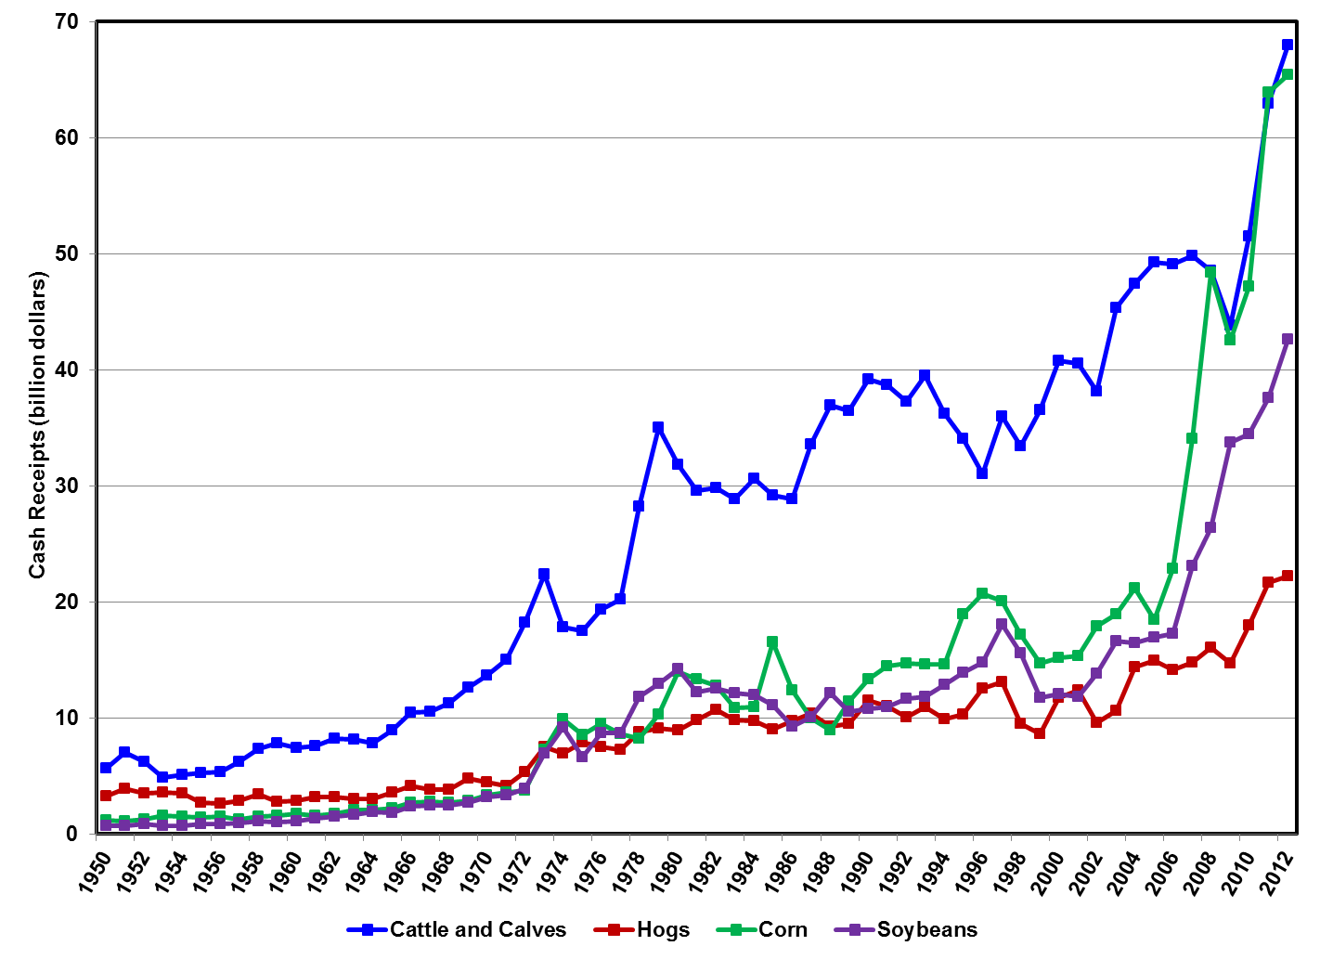

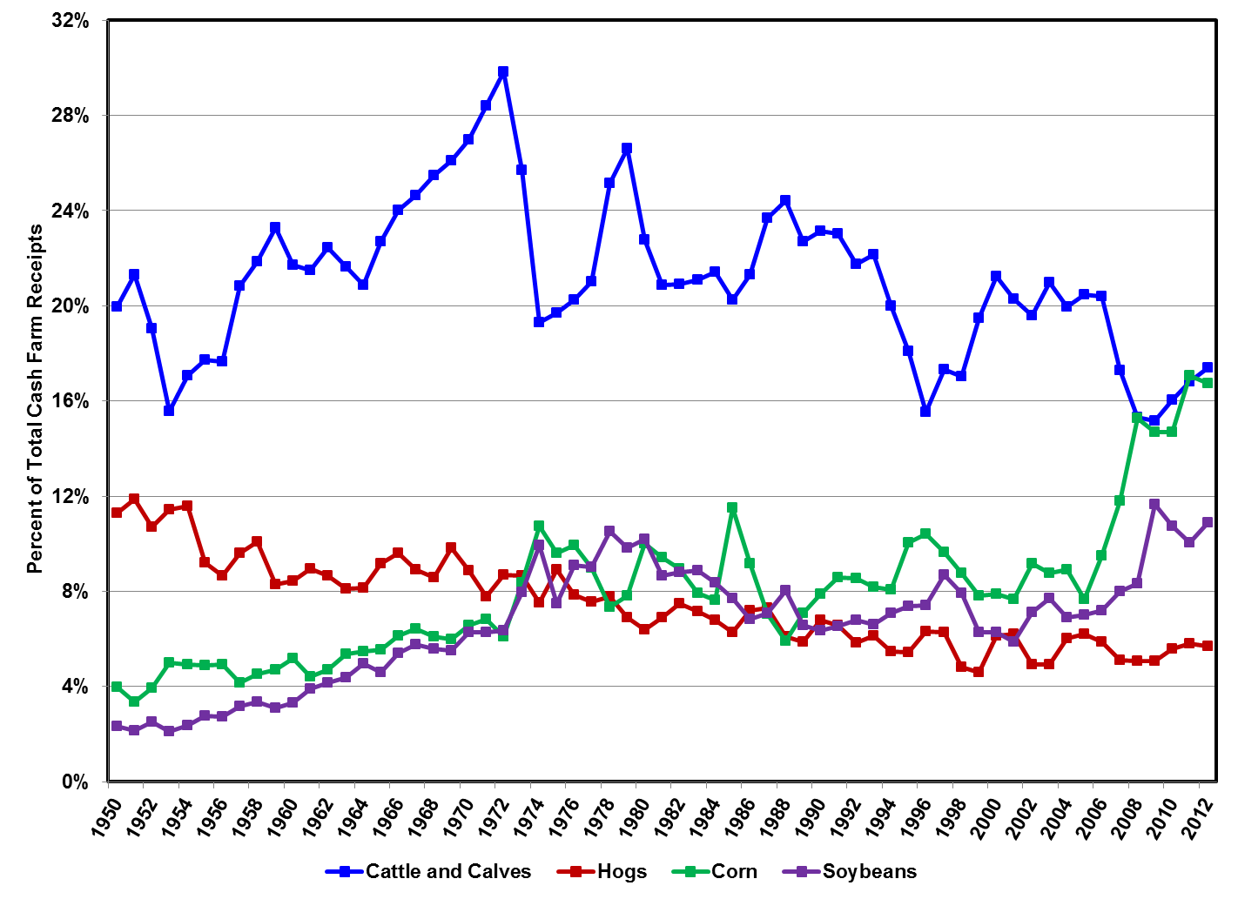

Data Source: USDA-ERS, 2012 estimated using USDA-NASS gross income

**Table 1. Livestock Prices and Corn Price Descriptive Statistics**

|  |  |  |  |  |
| --- | --- | --- | --- | --- |
|  | Average | Std. Dev. | Min | Max |
| January 1999 - December 2006 | |  |  |  |
| Live cattle, $/cwt | 80.50 | 11.06 | 62.20 | 101.00 |
| Feeder cattle, $/cwt | 96.48 | 14.25 | 70.90 | 121.50 |
| Live hogs, $/cwt | 42.64 | 8.17 | 26.90 | 57.60 |
| Feeder pigs, $/cwt | 108.23 | 30.00 | 37.00 | 179.00 |
| Corn, $/bu | 2.09 | 0.29 | 1.52 | 3.01 |
|  |  |  |  |  |
| January 2007 - May 2013 | |  |  |  |
| Live cattle, $/cwt | 104.31 | 15.74 | 83.80 | 132.00 |
| Feeder cattle, $/cwt | 117.53 | 20.21 | 92.60 | 160.60 |
| Live hogs, $/cwt | 54.76 | 10.43 | 37.60 | 76.10 |
| Feeder pigs, $/cwt | 125.65 | 41.97 | 42.00 | 205.00 |
| Corn, $/bu | 4.89 | 1.38 | 3.05 | 7.63 |

Data Source: USDA-NASS

**Table 2. Livestock Prices and Corn Price Correlation Matrix**

|  |  |  |  |  |  |
| --- | --- | --- | --- | --- | --- |
|  | Live Cattle | Feeder Cattle | Live Hogs | Feeder Pigs | Corn |
|  | ------------------- Levels ------------------ | | | | |
| January 1999 - December 2006 | |  |  |  |  |
| Live Cattle | 1.0000 |  |  |  |  |
| Feeder Cattle | 0.9047 | 1.0000 |  |  |  |
| Live Hogs | 0.6116 | 0.7238 | 1.0000 |  |  |
| Feeder Pigs | 0.5840 | 0.5322 | 0.5036 | 1.0000 |  |
| Corn | 0.3542 | 0.1625 | 0.1168 | 0.0328 | 1.0000 |
|  |  |  |  |  |  |
| January 2007 - May 2013 | |  |  |  |  |
| Fed Cattle | 1.0000 |  |  |  |  |
| Feeder Cattle | 0.9751 | 1.0000 |  |  |  |
| Live Hogs | 0.8133 | 0.7962 | 1.0000 |  |  |
| Feeder Pigs | 0.3098 | 0.3332 | 0.2802 | 1.0000 |  |
| Corn | 0.8733 | 0.8209 | 0.7660 | 0.0526 | 1.0000 |
|  |  |  |  |  |  |
|  | ------------------- Percentage Change by Month ------------------- | | | | |
| January 1999 - December 2006 | |  |  |  |  |
| Live Cattle | 1.0000 |  |  |  |  |
| Feeder Cattle | 0.5548 | 1.0000 |  |  |  |
| Live Hogs | 0.0041 | -0.0166 | 1.0000 |  |  |
| Feeder Pigs | 0.3799 | 0.0779 | 0.1423 | 1.0000 |  |
| Corn | 0.0139 | -0.2520 | -0.0028 | 0.0686 | 1.0000 |
|  |  |  |  |  |  |
| January 2007 - May 2013 | |  |  |  |  |
| Fed Cattle | 1.0000 |  |  |  |  |
| Feeder Cattle | 0.6721 | 1.0000 |  |  |  |
| Live Hogs | 0.1368 | 0.2113 | 1.0000 |  |  |
| Feeder Pigs | 0.2384 | 0.2636 | 0.1634 | 1.0000 |  |
| Corn | 0.0074 | -0.1344 | 0.3153 | -0.0082 | 1.0000 |

Data Source: USDA-NASS

**Figure 5. Feed Price Ratio, Steer & Heifer, (Corn to Live Weight) – Ratio Measured in BU/CWT, U.S., Annual**

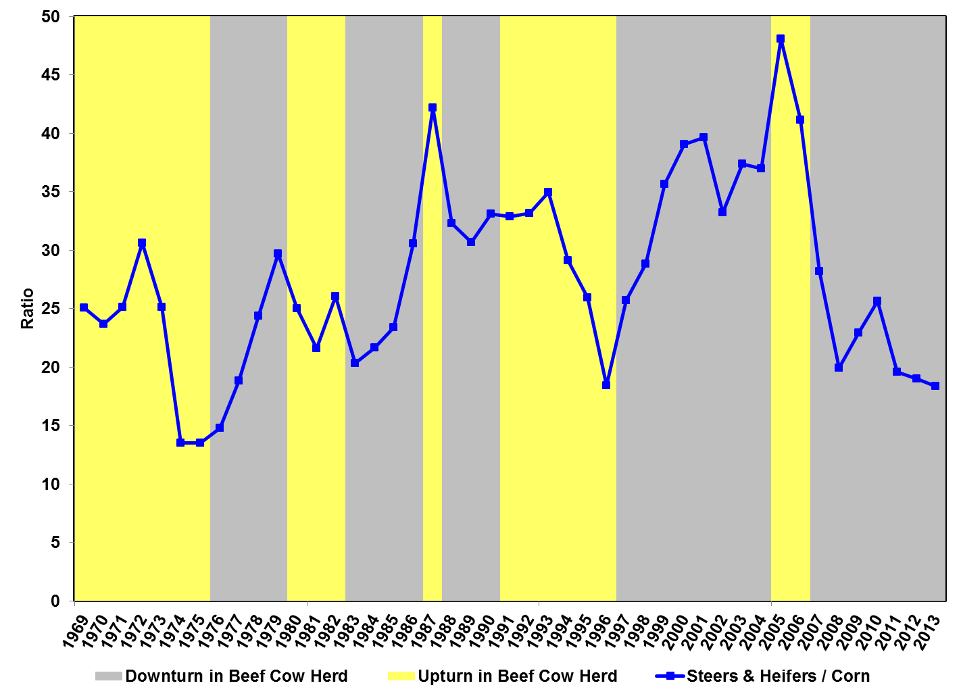

Data Source: USDA-NASS. Steer and heifer/corn ratio is the number of bushels of corn equal in value to 100 pounds of steers and heifers, live weight.

**Figure 6. Feed Price Ratio, Hogs, (Corn to Live Weight) – Ratio Measured in BU/CWT, U.S., Quarterly**

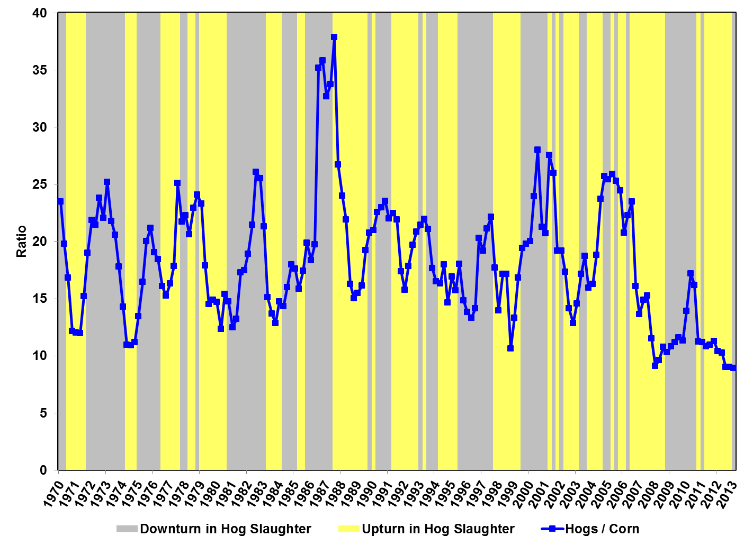

Data Source: USDA-NASS. Hog/corn ratio is the number of bushels of corn equal in value to 100 pounds of all hogs, live weight.

**Table 3. Average Year/Year Change in Beef Cow Herd and Hog Slaughter**

|  |  |  |
| --- | --- | --- |
|  | Steers & Heifers / Corn | Hogs / Corn |
| Sum | 60.67% | 112.03% |
| Count | 44 | 173 |
| Average | 1.38% | 0.65% |
| Upturn in Beef Cow Herd (Hog Slaughter) | | |
| Sum | -47.77% | -220.40% |
| Count | 18 | 88 |
| Average | -2.65% | -2.50% |
| Downturn in Beef Cow Herd (Hog Slaughter) | | |
| Sum | 108.44% | 332.44% |
| Count | 26 | 85 |
| Average | 4.17% | 3.91% |

Data Source: USDA-NASS.

**Figure 7. U.S. All Fresh Beef Demand Index**

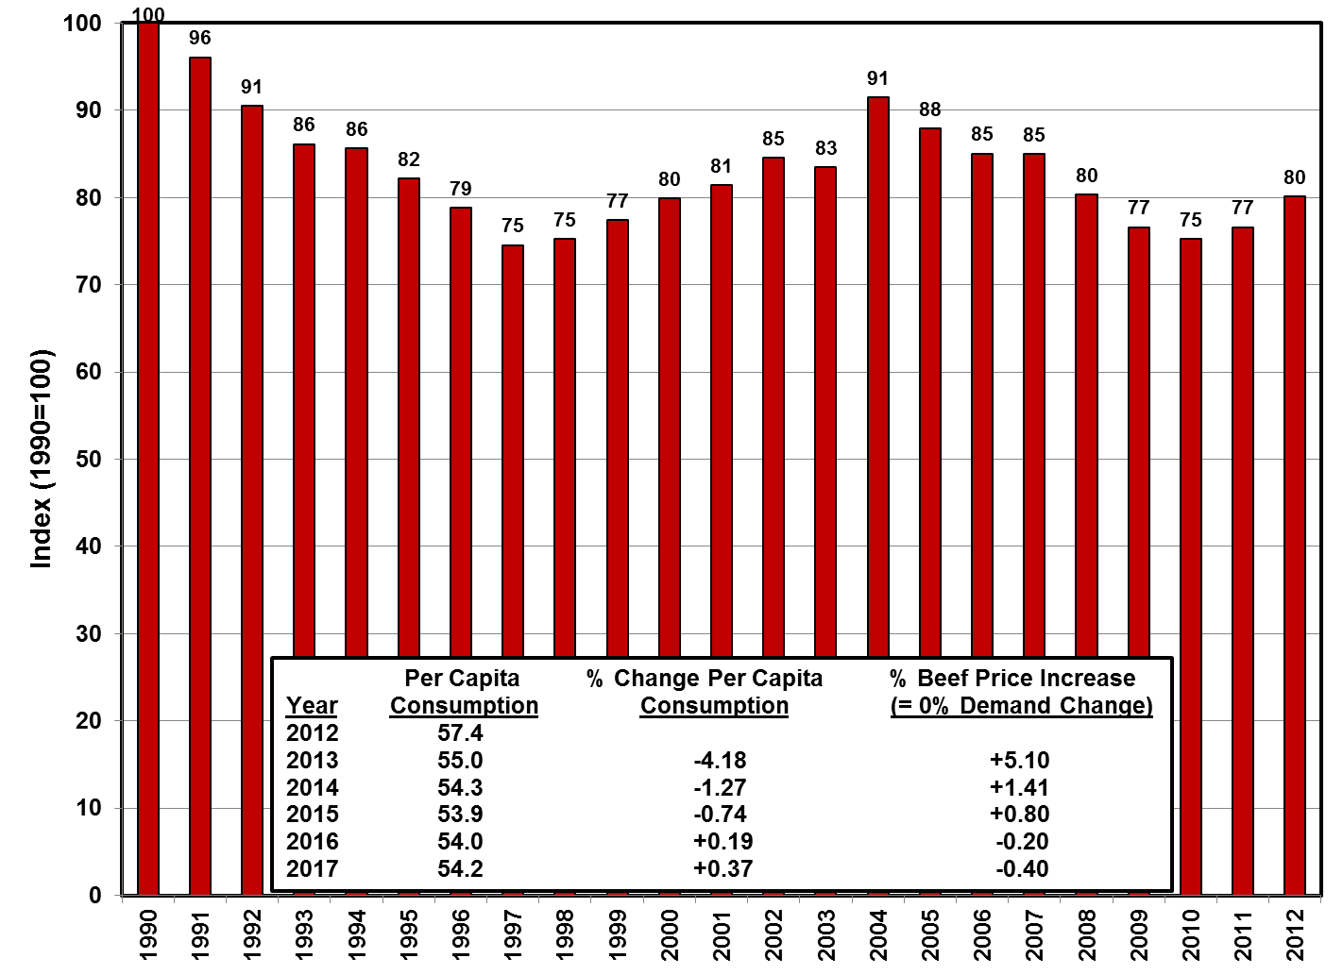

Data Source: Bureau of Labor Statistics, USDA-ERS, compiled by LMIC, FAPRI (projections), tabulations by Lee Schulz.

**Figure 8. U.S. Pork Beef Demand Index**

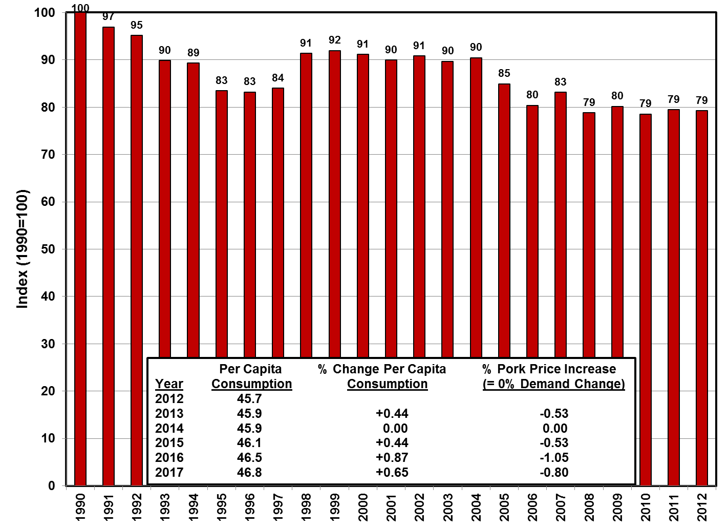

Data Source: Bureau of Labor Statistics, USDA-ERS, compiled by LMIC, FAPRI (projections), tabulations by Lee Schulz.